 |  | Substation |  |  | BERTAM VALLEY |  |  |  |  |  |  |  |  |  |  |  |  | Date: 02/06/2026
 |  | Equipment |  |  | RMU SF6 |  | Manufacturer |  |  |  |  |  |  |  |  | INDKOM |  | Time: 9:20 AM
 |  | Model |  |  | INS24 |  | Rating |  |  |  |  |  |  |  |  | 12kV |  | Humidity: 79%
 |  | Area |  |  | OVERVIEW |  |  |  |  |  |  |  |  |  |  | Panel No. |  | -
Panel Name |  | -
 | IR IMAGE |  |  |  |  |  |  |  |  |  |  | VISUAL IMAGE
 |  |  |  |  |  |  |  |  |  |  |  | 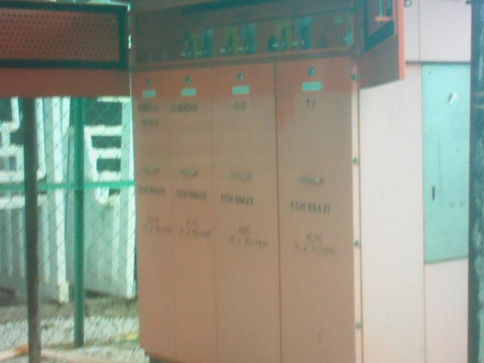
 | PARAMETER |  | VALUE
 | Spot Temp.1 (Sp1) |  | - |  |  |  |  |  |  |  |  |  |  |  | PARAMETER |  |  | VALUE
 | Spot Temp. 2 (Sp2) |  | - |  |  |  |  |  |  |  |  |  |  |  | Serial No. |  |  | 18072222340DE
 | Average Temp. (Ar1) |  | 24.2 °C |  |  |  |  |  |  |  |  |  |  |  | Heater (A) |  |  | -
 | Ambient Temp. |  | 21 °C |  |  |  |  |  |  |  |  |  |  |  | CB Position |  |  | -
 | Delta T ( ∆ T) |  | - |  |  |  |  |  |  |  |  |  |  |  | Busbar Position |  |  | -
 | Load (A) |  | - |  |  |  |  |  |  |  |  |  |  |  | Cable Type |  |  | -
 | Defect |  | -
 | ULTRASOUND IMAGE
 | 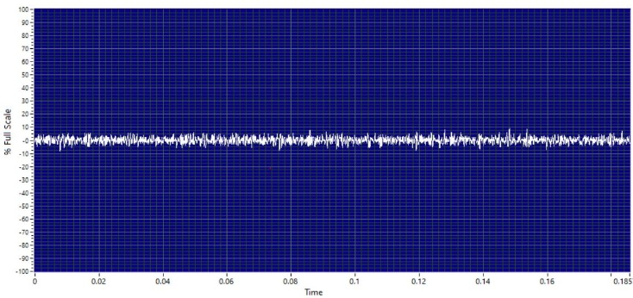
 | Decibel (dB) |  |  | -
 | Sound characteristic |  |  | -
 | Severity |  |  | -
 | Sound clip |  |  | 
Analysis & Recommendations:

Analysis: No Anomaly.
Recommendation: -

 |  | Substation |  |  | BERTAM VALLEY |  |  |  |  |  |  |  |  |  |  |  |  | Date: 02/06/2026
 |  | Equipment |  |  | RMU SF6 |  | Manufacturer |  |  |  |  |  |  |  |  | INDKOM |  | Time: 9:20 AM
 |  | Model |  |  | INS24 |  | Rating |  |  |  |  |  |  |  |  | 12kV |  | Humidity: 79%
 |  | Area |  |  | OVERVIEW TOP |  |  |  |  |  |  |  |  |  |  | Panel No. |  | -
Panel Name |  | -
 | IR IMAGE |  |  |  |  |  |  |  |  |  |  | VISUAL IMAGE
 |  |  |  |  |  |  |  |  |  |  |  | 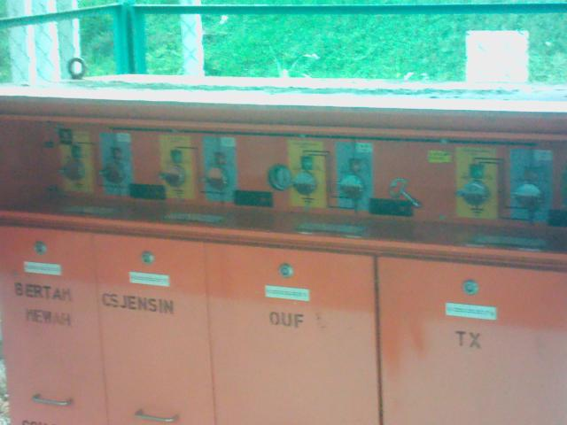
 | PARAMETER |  | VALUE
 | Spot Temp.1 (Sp1) |  | - |  |  |  |  |  |  |  |  |  |  |  | PARAMETER |  |  | VALUE
 | Spot Temp. 2 (Sp2) |  | - |  |  |  |  |  |  |  |  |  |  |  | Serial No. |  |  | 18072222340DE
 | Average Temp. (Ar1) |  | 23.7 °C |  |  |  |  |  |  |  |  |  |  |  | Heater (A) |  |  | -
 | Ambient Temp. |  | 21 °C |  |  |  |  |  |  |  |  |  |  |  | CB Position |  |  | -
 | Delta T ( ∆ T) |  | - |  |  |  |  |  |  |  |  |  |  |  | Busbar Position |  |  | -
 | Load (A) |  | - |  |  |  |  |  |  |  |  |  |  |  | Cable Type |  |  | -
 | Defect |  | -
 | ULTRASOUND IMAGE
 | 
 | Decibel (dB) |  |  | -
 | Sound characteristic |  |  | -
 | Severity |  |  | -
 | Sound clip |  |  | 
Analysis & Recommendations:

Analysis: No Anomaly.
Recommendation: -

 |  | Substation |  |  | BERTAM VALLEY |  |  |  |  |  |  |  |  |  |  |  |  | Date: 02/06/2026
 |  | Equipment |  |  | RMU SF6 |  | Manufacturer |  |  |  |  |  |  |  |  | INDKOM |  | Time: 9:20 AM
 |  | Model |  |  | INS24 |  | Rating |  |  |  |  |  |  |  |  | 12kV |  | Humidity: 79%
 |  | Area |  |  | CABLE COMPARTMENT |  |  |  |  |  |  |  |  |  |  | Panel No. |  | CCH00420
Panel Name |  | BERTAM MEWAH
 | IR IMAGE |  |  |  |  |  |  |  |  |  |  | VISUAL IMAGE
 |  |  |  |  |  |  |  |  |  |  |  | 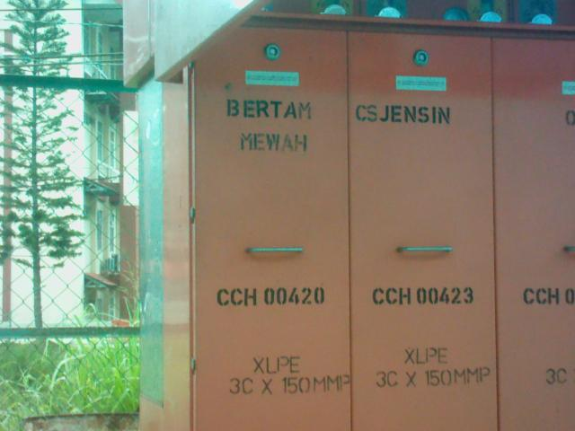
 | PARAMETER |  | VALUE
 | Spot Temp.1 (Sp1) |  | 24.0 °C |  |  |  |  |  |  |  |  |  |  |  | PARAMETER |  |  | VALUE
 | Spot Temp. 2 (Sp2) |  | 23.9 °C |  |  |  |  |  |  |  |  |  |  |  | Serial No. |  |  | 18072222340DE
 | Average Temp. (Ar1) |  | 24.1 °C |  |  |  |  |  |  |  |  |  |  |  | Heater (A) |  |  | -
 | Ambient Temp. |  | 21 °C |  |  |  |  |  |  |  |  |  |  |  | CB Position |  |  | CLOSE
 | Delta T ( ∆ T) |  | 0.1 °C |  |  |  |  |  |  |  |  |  |  |  | Busbar Position |  |  | -
 | Load (A) |  | - |  |  |  |  |  |  |  |  |  |  |  | Cable Type |  |  | NOT ACCESSIBLE
 | Defect
 | ULTRASOUND IMAGE
 | 
 | Decibel (dB) |  |  | (( panel.db_level }}
 | Sound characteristic |  |  | {{ panel.us.char }}
 | Severity
 | Sound clip |  |  | 
Analysis & Recommendations:
Analysis: No Anomaly.
Recommendation: -

 |  | Substation |  |  | BERTAM VALLEY |  |  |  |  |  |  |  |  |  |  |  |  | Date: 02/06/2026
 |  | Equipment |  |  | RMU SF6 |  | Manufacturer |  |  |  |  |  |  |  |  | INDKOM |  | Time: 9:20 AM
 |  | Model |  |  | INS24 |  | Rating |  |  |  |  |  |  |  |  | 12kV |  | Humidity: 79%
 |  | Area |  |  | CABLE COMPARTMENT |  |  |  |  |  |  |  |  |  |  | Panel No. |  | CCH00423
Panel Name |  | CS JENSIN
 | IR IMAGE |  |  |  |  |  |  |  |  |  |  | VISUAL IMAGE
 |  |  |  |  |  |  |  |  |  |  |  | 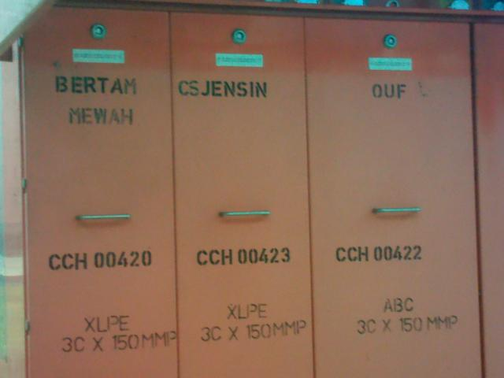
 | PARAMETER |  | VALUE
 | Spot Temp.1 (Sp1) |  | 23.7 °C |  |  |  |  |  |  |  |  |  |  |  | PARAMETER |  |  | VALUE
 | Spot Temp. 2 (Sp2) |  | 23.7 °C |  |  |  |  |  |  |  |  |  |  |  | Serial No. |  |  | 18072222340DE
 | Average Temp. (Ar1) |  | 23.9 °C |  |  |  |  |  |  |  |  |  |  |  | Heater (A) |  |  | -
 | Ambient Temp. |  | 21 °C |  |  |  |  |  |  |  |  |  |  |  | CB Position |  |  | CLOSE
 | Delta T ( ∆ T) |  | 0.0 °C |  |  |  |  |  |  |  |  |  |  |  | Busbar Position |  |  | -
 | Load (A) |  | - |  |  |  |  |  |  |  |  |  |  |  | Cable Type |  |  | NOT ACCESSIBLE
 | Defect
 | ULTRASOUND IMAGE
 | 
 | Decibel (dB) |  |  | (( panel.db_level }}
 | Sound characteristic |  |  | {{ panel.us.char }}
 | Severity
 | Sound clip |  |  | 
Analysis & Recommendations:
Analysis: No Anomaly.
Recommendation: -

 |  | Substation |  |  | BERTAM VALLEY |  |  |  |  |  |  |  |  |  |  |  |  | Date: 02/06/2026
 |  | Equipment |  |  | RMU SF6 |  | Manufacturer |  |  |  |  |  |  |  |  | INDKOM |  | Time: 9:20 AM
 |  | Model |  |  | INS24 |  | Rating |  |  |  |  |  |  |  |  | 12kV |  | Humidity: 79%
 |  | Area |  |  | CABLE COMPARTMENT |  |  |  |  |  |  |  |  |  |  | Panel No. |  | CCH00422
Panel Name |  | OUF
 | IR IMAGE |  |  |  |  |  |  |  |  |  |  | VISUAL IMAGE
 |  |  |  |  |  |  |  |  |  |  |  | 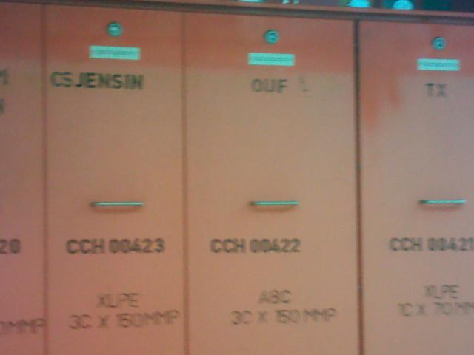
 | PARAMETER |  | VALUE
 | Spot Temp.1 (Sp1) |  | 23.7 °C |  |  |  |  |  |  |  |  |  |  |  | PARAMETER |  |  | VALUE
 | Spot Temp. 2 (Sp2) |  | 23.8 °C |  |  |  |  |  |  |  |  |  |  |  | Serial No. |  |  | 18072222340DE
 | Average Temp. (Ar1) |  | 23.9 °C |  |  |  |  |  |  |  |  |  |  |  | Heater (A) |  |  | -
 | Ambient Temp. |  | 21 °C |  |  |  |  |  |  |  |  |  |  |  | CB Position |  |  | CLOSE
 | Delta T ( ∆ T) |  | 0.0 °C |  |  |  |  |  |  |  |  |  |  |  | Busbar Position |  |  | -
 | Load (A) |  | - |  |  |  |  |  |  |  |  |  |  |  | Cable Type |  |  | NOT ACCESSIBLE
 | Defect
 | ULTRASOUND IMAGE
 | 
 | Decibel (dB) |  |  | (( panel.db_level }}
 | Sound characteristic |  |  | {{ panel.us.char }}
 | Severity
 | Sound clip |  |  | 
Analysis & Recommendations:
Analysis: No Anomaly.
Recommendation: -

 |  | Substation |  |  | BERTAM VALLEY |  |  |  |  |  |  |  |  |  |  |  |  | Date: 02/06/2026
 |  | Equipment |  |  | RMU SF6 |  | Manufacturer |  |  |  |  |  |  |  |  | INDKOM |  | Time: 9:20 AM
 |  | Model |  |  | INS24 |  | Rating |  |  |  |  |  |  |  |  | 12kV |  | Humidity: 79%
 |  | Area |  |  | CABLE COMPARTMENT |  |  |  |  |  |  |  |  |  |  | Panel No. |  | CCH00421
Panel Name |  | TX
 | IR IMAGE |  |  |  |  |  |  |  |  |  |  | VISUAL IMAGE
 |  |  |  |  |  |  |  |  |  |  |  | 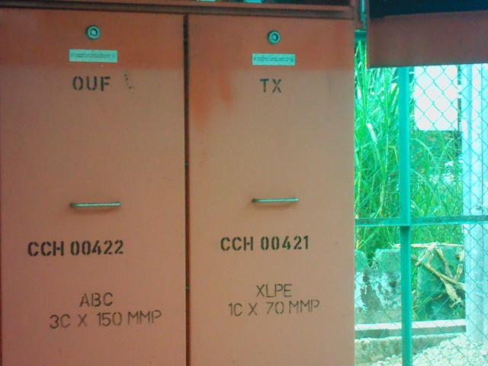
 | PARAMETER |  | VALUE
 | Spot Temp.1 (Sp1) |  | 24.2 °C |  |  |  |  |  |  |  |  |  |  |  | PARAMETER |  |  | VALUE
 | Spot Temp. 2 (Sp2) |  | 24.3 °C |  |  |  |  |  |  |  |  |  |  |  | Serial No. |  |  | 18072222340DE
 | Average Temp. (Ar1) |  | 24.3 °C |  |  |  |  |  |  |  |  |  |  |  | Heater (A) |  |  | -
 | Ambient Temp. |  | 21 °C |  |  |  |  |  |  |  |  |  |  |  | CB Position |  |  | CLOSE
 | Delta T ( ∆ T) |  | 0.1 °C |  |  |  |  |  |  |  |  |  |  |  | Busbar Position |  |  | -
 | Load (A) |  | - |  |  |  |  |  |  |  |  |  |  |  | Cable Type |  |  | NOT ACCESSIBLE
 | Defect
 | ULTRASOUND IMAGE
 | 
 | Decibel (dB) |  |  | (( panel.db_level }}
 | Sound characteristic |  |  | {{ panel.us.char }}
 | Severity
 | Sound clip |  |  | 
Analysis & Recommendations:
Analysis: No Anomaly.
Recommendation: -

 |  | Substation |  |  | BERTAM VALLEY |  |  |  |  |  |  |  |  |  |  |  |  | Date: 02/06/2026
 |  | Equipment |  |  | TRANSFORMER |  | Manufacturer |  |  |  |  |  |  |  |  | EWT |  | Time: 9:20 AM
 |  | Model |  |  | HERMETICALLY SEAL |  | Rating |  |  |  |  |  |  |  |  | 750kVA |  | Humidity: 79%
 |  | Area |  |  | OVERVIEW |  |  |  |  |  |  |  |  |  |  | Tx No. |  | 1
Location
 | IR IMAGE |  |  |  |  |  |  |  |  |  |  | VISUAL IMAGE
 |  |  |  |  |  |  |  |  |  |  |  | 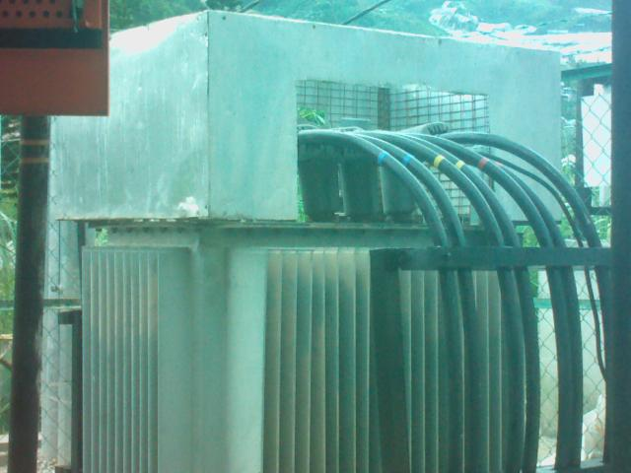
 | PARAMETER |  | VALUE
 | Spot Temp.1 (Sp1) |  | 31.7 °C |  |  |  |  |  |  |  |  |  |  |  | PARAMETER |  |  | VALUE
 | Spot Temp. 2 (Sp2) |  | 35.7 °C |  |  |  |  |  |  |  |  |  |  |  | Serial No. |  |  | EWT55674
 | Average Temp. (Ar1) |  | 34.6 °C |  |  |  |  |  |  |  |  |  |  |  | Heater (A) |  |  | -
 | Ambient Temp. |  | 21 °C |  |  |  |  |  |  |  |  |  |  |  | CB Position |  |  | -
 | Delta T ( ∆ T) |  | 4.0 °C |  |  |  |  |  |  |  |  |  |  |  | Busbar Position |  |  | -
 | Load (A) |  | - |  |  |  |  |  |  |  |  |  |  |  | Cable Type |  |  | -
 | Defect |  | -
 | ULTRASOUND IMAGE
 | 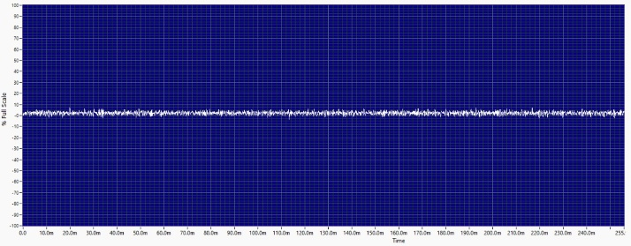
 | Decibel (dB) |  |  | -
 | Sound characteristic |  |  | -
 | Defect |  |  | -
 | Sound clip |  |  | 

Analysis & Recommendations:
Analysis: No Anomaly.
Recommendation: -

 |  | Substation |  |  | BERTAM VALLEY |  |  |  |  |  |  |  |  |  |  |  |  | Date: 02/06/2026
 |  | Equipment |  |  | TRANSFORMER |  | Manufacturer |  |  |  |  |  |  |  |  | EWT |  | Time: 9:20 AM
 |  | Model |  |  | HERMETICALLY SEAL |  | Rating |  |  |  |  |  |  |  |  | 750kVA |  | Humidity: 79%
 |  | Area |  |  | BUSHING |  |  |  |  |  |  |  |  |  |  | Tx No. |  | 1
Location |  | HV SIDE
 | IR IMAGE |  |  |  |  |  |  |  |  |  |  | VISUAL IMAGE
 |  |  |  |  |  |  |  |  |  |  |  | 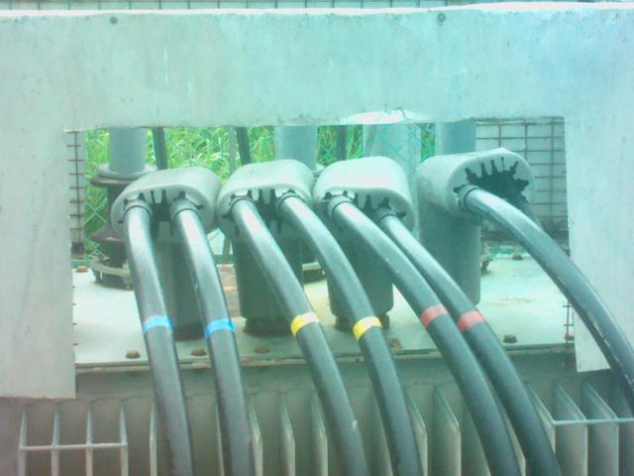
 | PARAMETER |  | VALUE
 | Spot Temp.1 (Sp1) |  | 26.9 °C |  |  |  |  |  |  |  |  |  |  |  | PARAMETER |  |  | VALUE
 | Spot Temp. 2 (Sp2) |  | 28.6 °C |  |  |  |  |  |  |  |  |  |  |  | Serial No. |  |  | EWT55674
 | Average Temp. (Ar1) |  | 28.3 °C |  |  |  |  |  |  |  |  |  |  |  | Heater (A) |  |  | -
 | Ambient Temp. |  | 21 °C |  |  |  |  |  |  |  |  |  |  |  | CB Position |  |  | -
 | Delta T ( ∆ T) |  | -1.6 °C |  |  |  |  |  |  |  |  |  |  |  | Busbar Position |  |  | -
 | Load (A) |  | - |  |  |  |  |  |  |  |  |  |  |  | Cable Type |  |  | XLPE
 | Defect
 | ULTRASOUND IMAGE
 | 
 | Decibel (dB) |  |  | 0dB
 | Sound characteristic |  |  | Normal
 | Severity
 | Sound clip |  |  | 
Analysis & Recommendations:
Analysis: No Anomaly.
Recommendation: -

 |  | Substation |  |  | BERTAM VALLEY |  |  |  |  |  |  |  |  |  |  |  |  | Date: 02/06/2026
 |  | Equipment |  |  | TRANSFORMER |  | Manufacturer |  |  |  |  |  |  |  |  | EWT |  | Time: 9:20 AM
 |  | Model |  |  | HERMETICALLY SEAL |  | Rating |  |  |  |  |  |  |  |  | 750kVA |  | Humidity: 79%
 |  | Area |  |  | CABLE |  |  |  |  |  |  |  |  |  |  | Tx No. |  | 1
Location |  | HV SIDE
 | IR IMAGE |  |  |  |  |  |  |  |  |  |  | VISUAL IMAGE
 |  |  |  |  |  |  |  |  |  |  |  | 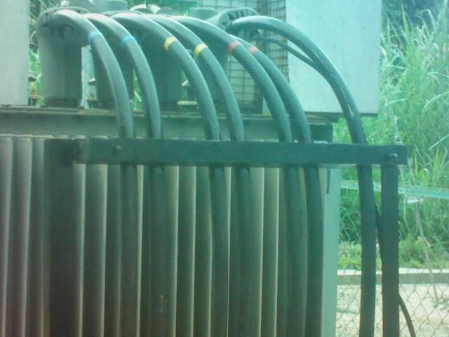
 | PARAMETER |  | VALUE
 | Spot Temp.1 (Sp1) |  | 26.5 °C |  |  |  |  |  |  |  |  |  |  |  | PARAMETER |  |  | VALUE
 | Spot Temp. 2 (Sp2) |  | 26.1 °C |  |  |  |  |  |  |  |  |  |  |  | Serial No. |  |  | EWT55674
 | Average Temp. (Ar1) |  | 28.4 °C |  |  |  |  |  |  |  |  |  |  |  | Heater (A) |  |  | -
 | Ambient Temp. |  | 21 °C |  |  |  |  |  |  |  |  |  |  |  | CB Position |  |  | -
 | Delta T ( ∆ T) |  | 0.5 °C |  |  |  |  |  |  |  |  |  |  |  | Busbar Position |  |  | -
 | Load (A) |  | - |  |  |  |  |  |  |  |  |  |  |  | Cable Type |  |  | XLPE
 | Defect
 | ULTRASOUND IMAGE
 | 
 | Decibel (dB) |  |  | 0dB
 | Sound characteristic |  |  | Normal
 | Severity
 | Sound clip |  |  | 
Analysis & Recommendations:
Analysis: No Anomaly.
Recommendation: -

 |  | Substation |  |  | BERTAM VALLEY |  |  |  |  |  |  |  |  |  |  |  |  | Date: 02/06/2026
 |  | Equipment |  |  | TRANSFORMER |  | Manufacturer |  |  |  |  |  |  |  |  | EWT |  | Time: 9:20 AM
 |  | Model |  |  | HERMETICALLY SEAL |  | Rating |  |  |  |  |  |  |  |  | 750kVA |  | Humidity: 79%
 |  | Area |  |  | BUSHING |  |  |  |  |  |  |  |  |  |  | Tx No. |  | 1
Location |  | LV SIDE
 | IR IMAGE |  |  |  |  |  |  |  |  |  |  | VISUAL IMAGE
 |  |  |  |  |  |  |  |  |  |  |  | 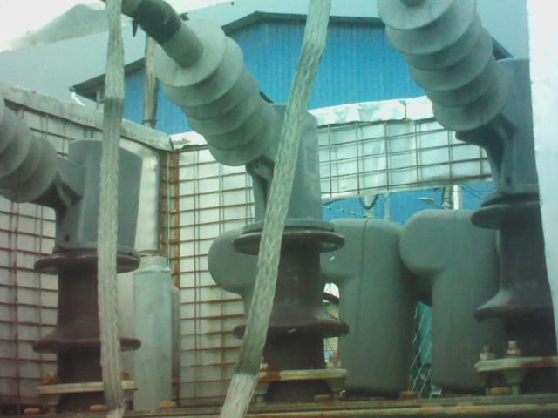
 | PARAMETER |  | VALUE
 | Spot Temp.1 (Sp1) |  | 25.8 °C |  |  |  |  |  |  |  |  |  |  |  | PARAMETER |  |  | VALUE
 | Spot Temp. 2 (Sp2) |  | 28.9 °C |  |  |  |  |  |  |  |  |  |  |  | Serial No. |  |  | EWT55674
 | Average Temp. (Ar1) |  | 26.5 °C |  |  |  |  |  |  |  |  |  |  |  | Heater (A) |  |  | -
 | Ambient Temp. |  | 21 °C |  |  |  |  |  |  |  |  |  |  |  | CB Position |  |  | -
 | Delta T ( ∆ T) |  | 3.2 °C |  |  |  |  |  |  |  |  |  |  |  | Busbar Position |  |  | -
 | Load (A) |  | - |  |  |  |  |  |  |  |  |  |  |  | Cable Type |  |  | XLPE
 | Defect
Analysis & Recommendations:

Analysis: No Anomaly.
Recommendation: -

 |  | Substation |  |  | BERTAM VALLEY |  |  |  |  |  |  |  |  |  |  |  |  | Date: 02/06/2026
 |  | Equipment |  |  | TRANSFORMER |  | Manufacturer |  |  |  |  |  |  |  |  | EWT |  | Time: 9:20 AM
 |  | Model |  |  | HERMETICALLY SEAL |  | Rating |  |  |  |  |  |  |  |  | 750kVA |  | Humidity: 79%
 |  | Area |  |  | CABLE |  |  |  |  |  |  |  |  |  |  | Tx No. |  | 1
Location |  | LV SIDE
 | IR IMAGE |  |  |  |  |  |  |  |  |  |  | VISUAL IMAGE
 |  |  |  |  |  |  |  |  |  |  |  | 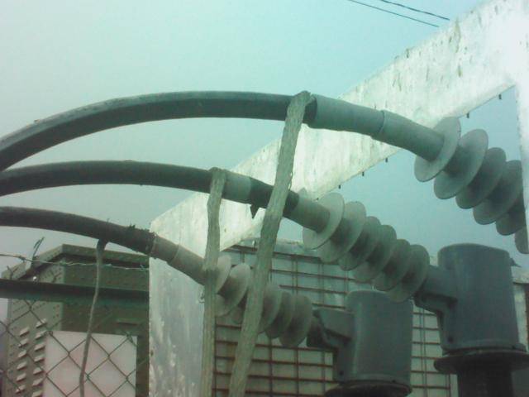
 | PARAMETER |  | VALUE
 | Spot Temp.1 (Sp1) |  | 21.5 °C |  |  |  |  |  |  |  |  |  |  |  | PARAMETER |  |  | VALUE
 | Spot Temp. 2 (Sp2) |  | 24.8 °C |  |  |  |  |  |  |  |  |  |  |  | Serial No. |  |  | EWT55674
 | Average Temp. (Ar1) |  | 23.3 °C |  |  |  |  |  |  |  |  |  |  |  | Heater (A) |  |  | -
 | Ambient Temp. |  | 21 °C |  |  |  |  |  |  |  |  |  |  |  | CB Position |  |  | -
 | Delta T ( ∆ T) |  | 3.3 °C |  |  |  |  |  |  |  |  |  |  |  | Busbar Position |  |  | -
 | Load (A) |  | - |  |  |  |  |  |  |  |  |  |  |  | Cable Type |  |  | XLPE
 | Defect
Analysis & Recommendations:

Analysis: No Anomaly.
Recommendation: -

 |  | Substation |  |  | BERTAM VALLEY |  |  |  |  |  |  |  |  |  |  |  |  | Date: 02/06/2026
 |  | Equipment |  |  | FP TX1 |  | Manufacturer |  |  |  |  |  |  |  |  | PSB |  | Time: 9:20 AM
 |  | Model |  |  | DIN TYPE |  | Rating |  |  |  |  |  |  |  |  | 1600A |  | Humidity: 79%
 |  | Area |  |  | OVERVIEW |  |  |  |  |  |  |  |  |  |  | Feeder No. |  | -
Feeder Name |  | -
 | IR IMAGE |  |  |  |  |  |  |  |  |  |  | VISUAL IMAGE
 |  |  |  |  |  |  |  |  |  |  |  | 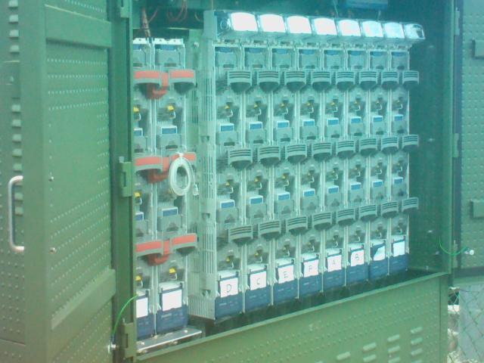
 | PARAMETER |  | VALUE
 | Spot Temp.1 (Sp1) |  | - |  |  |  |  |  |  |  |  |  |  |  | PARAMETER |  |  | VALUE
 | Spot Temp. 2 (Sp2) |  | - |  |  |  |  |  |  |  |  |  |  |  | Serial No. |  |  | RTLR 642-045
 | Average Temp. (Ar1) |  | 27.3 °C |  |  |  |  |  |  |  |  |  |  |  | Heater (A) |  |  | -
 | Ambient Temp. |  | 21 °C |  |  |  |  |  |  |  |  |  |  |  | CB Position |  |  | -
 | Delta T ( ∆ T) |  | - |  |  |  |  |  |  |  |  |  |  |  | Busbar Position |  |  | -
 | Load (A) |  | - |  |  |  |  |  |  |  |  |  |  |  | Cable Type |  |  | -
 | Defect |  | -
Analysis & Recommendations:

Analysis: No Anomaly.
Recommendation: -

